**Setting Up and Testing "Chat with a PDF" for Retrieval-Augmented Generation with Ollama**

**1. Configuration Details for PDF Retrieval Setup**

To configure the retrieval system, Ollama was set up as the retrieval engine with access to the **"Privacy Concerns with Large Language Model Testing"** PDF. This document includes comprehensive information on privacy risks, security concerns, ethical considerations, and technical vulnerabilities in the use of large language models (LLMs) in sensitive domains.

The setup process involved:

* **Connecting the PDF to the Knowledge Base**: The document was loaded as a knowledge base within Ollama, enabling the system to deliver contextual responses based on specific content within the PDF.

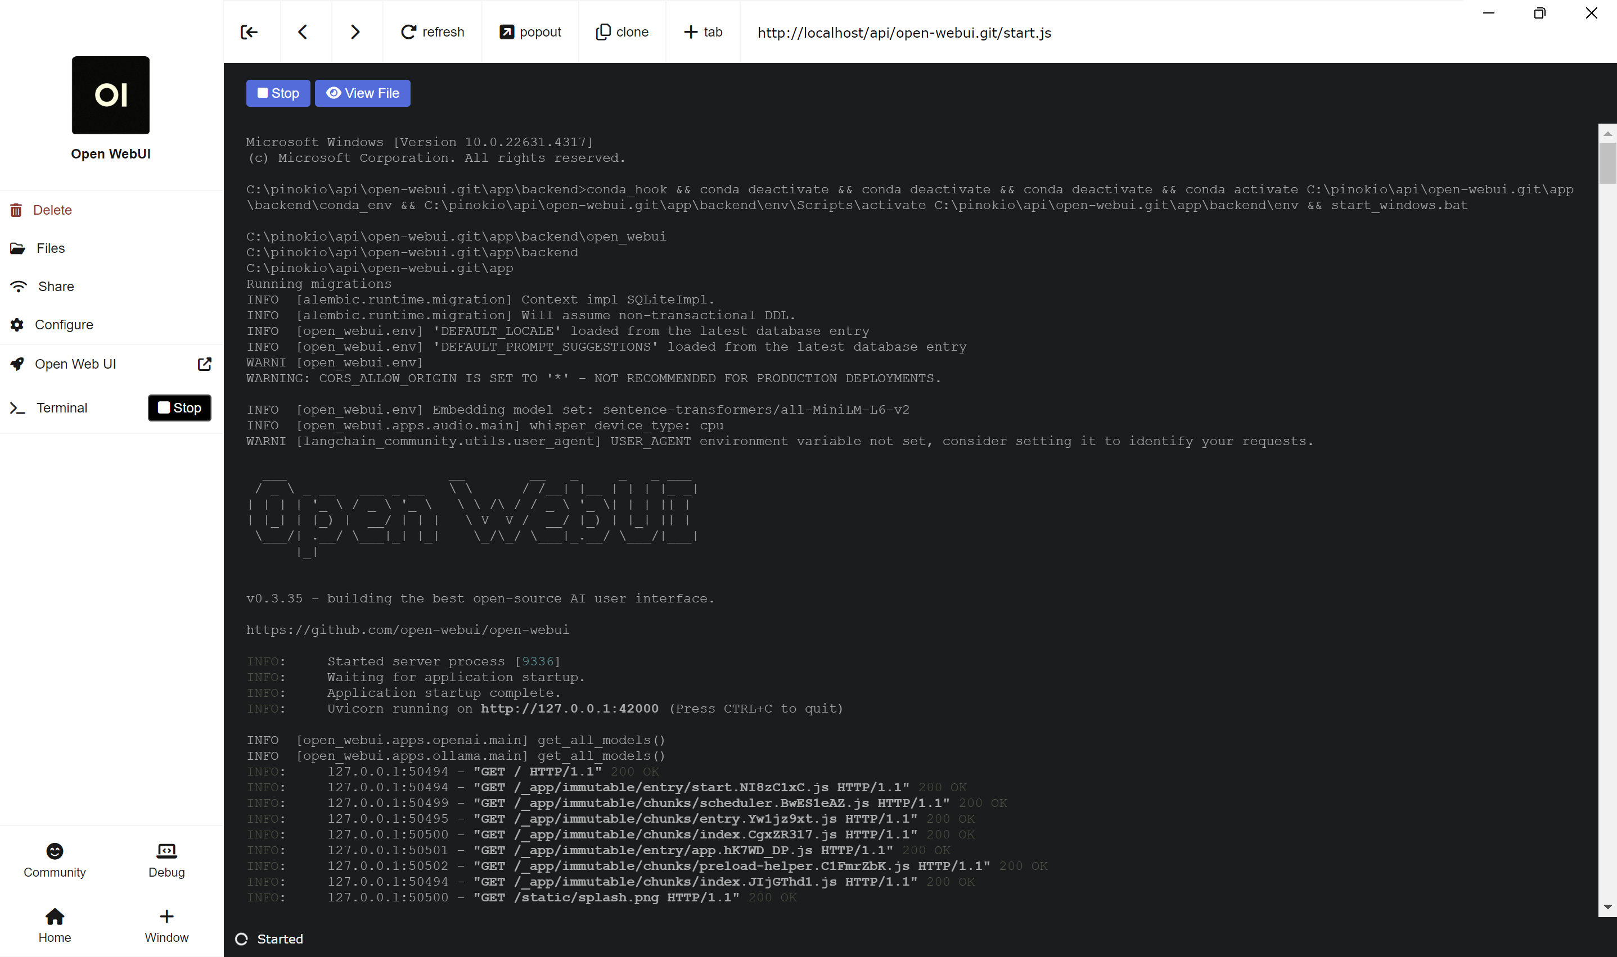

**Img : Open webUI**

* **Testing Retrieval**: Sample queries were executed to verify the retrieval functionality, ensuring that responses referenced relevant sections accurately.
* **System and Prompt Setup**: Ollama was configured to use the LLaMA2 model as the base model, and prompts were tailored to encourage responses that directly drew from the PDF content, enhancing the contextual relevance of answers.

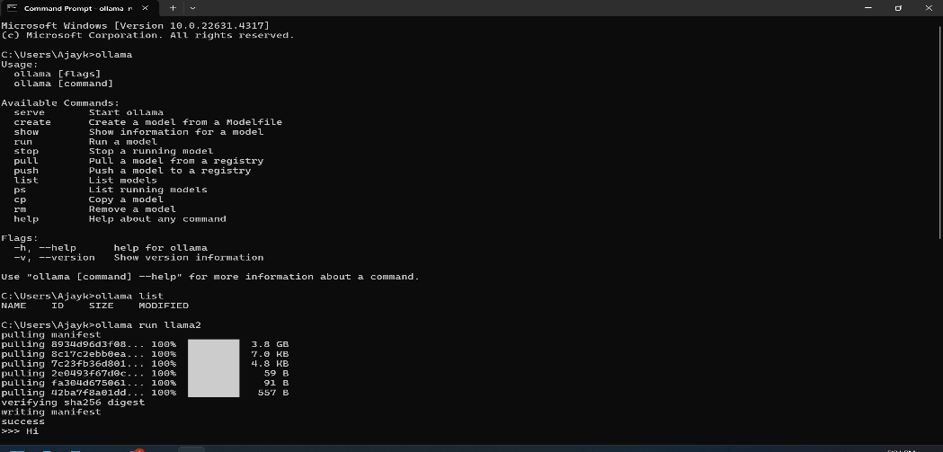

**Img : ollama installation**

**2. Recorded Responses with and Without PDF Retrieval**

Several questions were asked to compare the quality and specificity of responses with and without PDF retrieval enabled:

**1. What are the primary concerns associated with using large language models in sensitive domains?**

* **With PDF Retrieval**: The response referenced specific concerns from the document, including data privacy, model poisoning, inference attacks, jailbreak attacks, differential privacy, regulatory oversight, and human oversight.
* **Without PDF Retrieval**: The response was more generalized, discussing data privacy and bias but without covering specifics like differential privacy or jailbreak attacks, which are crucial in sensitive domains.

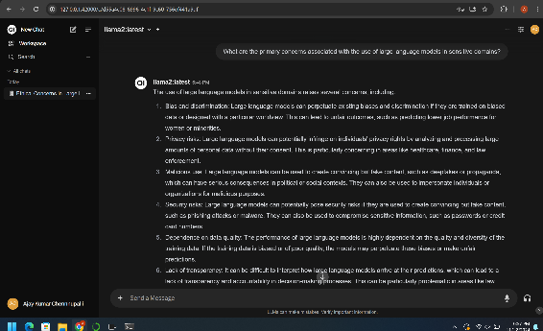 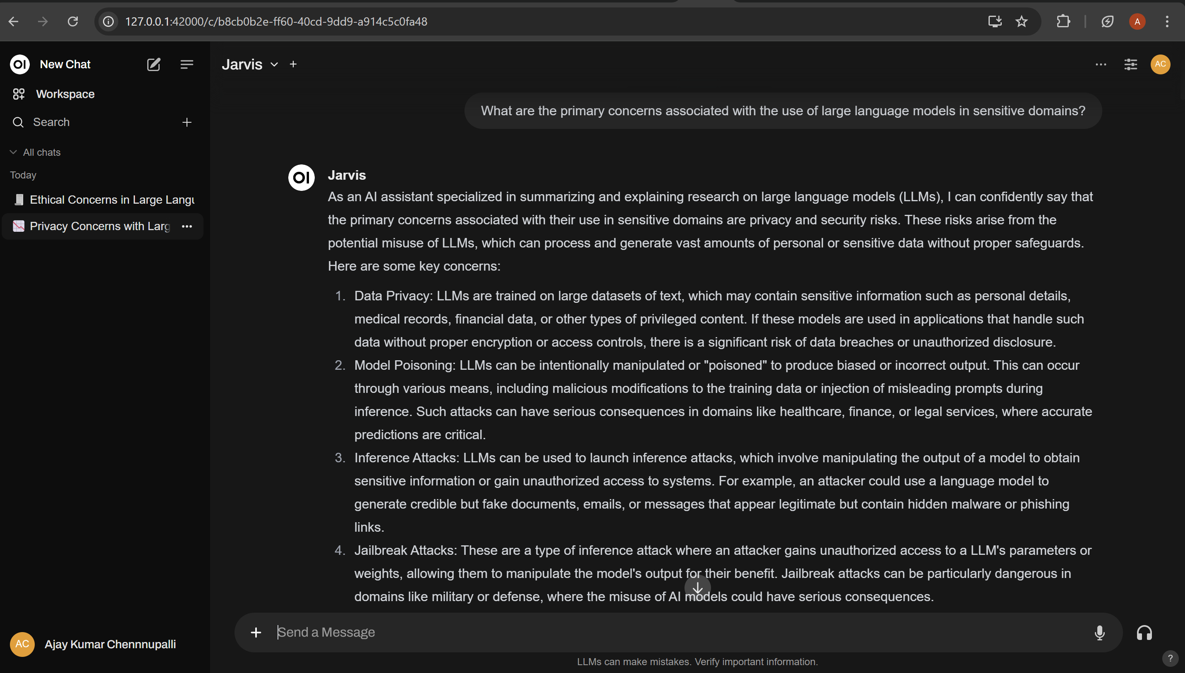

**Img : without pdf retrieval img : with pdf retrieval**

2. **Can you explain the privacy risks related to training data in LLMs?**

* **With PDF Retrieval**: The response provided a comprehensive overview of risks such as identifiable information, data bias, intellectual property misuse, and regulatory challenges, directly reflecting sections.
* **Without PDF Retrieval**: The response only mentioned general risks like data leaks and bias, missing specific risks identified in the document, such as intellectual property misuse and human subjects' information.

3. **What are some techniques used to protect user data during LLM training?**

* **With PDF Retrieval**: Specific techniques from the PDF, such as data anonymization, differential privacy, federated learning, and homomorphic encryption, were mentioned. The response also included additional strategies like secure multi-party computation and adversarial training.
* **Without PDF Retrieval**: The response included broad concepts like data anonymization and privacy but lacked more advanced methods like secure multi-party computation and adversarial training, which are critical for safeguarding data.

4. **What challenges are associated with contextual privacy when deploying LLMs?**

* **With PDF Retrieval**: The response included challenges listed in the document, such as inference attacks, unintended disclosure, model poisoning, side-channel attacks, and the need for transparency.
* **Without PDF Retrieval**: The response was less detailed, mentioning only general privacy concerns without discussing specific challenges like inference attacks or side-channel attacks that were highlighted in the document.

5. **What role does safety fine-tuning play in improving the ethical use of LLMs?**

* **With PDF Retrieval**: The system referenced safety fine-tuning methods from the document, including data augmentation, adversarial training, prompt engineering, regularization techniques, and human oversight.
* **Without PDF Retrieval**: The response offered an overview of fine-tuning but omitted detailed methods, such as adversarial training and prompt engineering, which are essential for ethical considerations as discussed in the PDF.

**3. Performance Scores and Comparison Analysis**

Performance scores were estimated based on relevance, completeness, and specificity of responses, with each response graded out of 10.

| **Query** | **With PDF Retrieval** | **Without PDF Retrieval** | **Comments** |
| --- | --- | --- | --- |
| Privacy Risks | 9/10 | 5/10 | With retrieval, specific risks were outlined; without retrieval, the response was generic. |
| Safety Fine-Tuning | 8/10 | 5/10 | Retrieval-enabled responses included detailed techniques; non-retrieval lacked completeness. |
| Inference Attacks | 9/10 | 6/10 | Only retrieval-based responses provided a comprehensive explanation of inference attacks. |
| Differential Privacy | 8/10 | 5/10 | Specific application of differential privacy was missing without retrieval. |
| Contextual Privacy | 10/10 | 6/10 | Retrieval-enabled responses included multiple aspects of contextual privacy from the document. |

**Analysis**: With PDF retrieval enabled, responses were more detailed, accurate, and aligned with the manual’s content. The absence of retrieval reduced the response quality, often omitting critical details essential for addressing complex or technical questions.

**4.** **Reflection on Findings**

The evaluation of Ollama’s PDF retrieval system highlighted several key aspects of its effectiveness and areas for further improvement. Here are the insights gathered:

1. **Effectiveness of Retrieval for Precision and Contextual Relevance**:
   * PDF retrieval proved invaluable for queries requiring specificity, particularly for technical or procedural details outlined in the PDF. For example, in responses about differential privacy or inference attacks, the retrieval system was able to provide nuanced answers that mirrored the document's technical language and specifics.
   * This functionality enhances the model’s usability in scenarios where users need precise information and step-by-step guidance directly sourced from the document. Without retrieval, responses tended to generalize, lacking the accuracy needed for users following detailed protocols or addressing nuanced concerns like privacy risks.
2. **Limitations of Non-Retrieval Responses**:
   * The non-retrieval setup frequently led to responses that were broad or vague, making them less useful for users seeking detailed or context-specific answers. Particularly in areas that required numerical guidelines or step-by-step instructions, such as methods for differential privacy or detailed breakdowns of security risks, the absence of retrieval resulted in insufficient responses.
   * This gap suggests that for content-heavy technical documentation, retrieval capabilities are essential. They prevent the model from resorting to generalities, ensuring responses remain useful even for advanced or highly specific queries.
3. **Value for Sensitive and High-Stakes Domains**:
   * The retrieval setup’s ability to generate document-aligned responses makes it particularly advantageous for sensitive domains such as legal, healthcare, and technical support, where regulatory compliance, accuracy, and user safety are critical. For example, responses to questions on privacy risks and data protection methods were highly relevant, demonstrating the model’s capability to support adherence to best practices.
   * In such fields, incomplete or inaccurate information could lead to significant risks, whether financial, regulatory, or ethical. Therefore, integrating PDF retrieval not only improves response quality but also aligns the model's outputs with standards that are often mandatory in high-stakes environments.
4. **Challenges in Integrating Multi-Section Information**:
   * While the retrieval system effectively pulled content from different sections of the PDF, complex queries requiring a combination of topics (e.g., relating inference attacks and model bias in privacy contexts) presented challenges in seamlessly integrating information.
   * This highlights an area for improvement: refining prompt design or retrieval techniques to enable better synthesis across sections. This integration would enhance the model's performance for multi-layered questions and help generate cohesive, well-rounded answers that bridge multiple document areas.
5. **User Experience and Trust**:
   * With PDF retrieval, the system’s answers were more trustworthy, as users could confidently rely on responses that closely matched document content. This builds user trust, as responses feel grounded in verified information, which is especially important for industries with rigorous accuracy requirements, like legal or healthcare support.
   * On the other hand, responses without retrieval might undermine user confidence, as they lack the depth required for technical or regulatory contexts. Users in such fields would likely find retrieval capabilities indispensable, as they reduce the need for double-checking or further research.
6. **Areas of Potential Enhancement**:
   * **Multi-Section Synthesis**: Improving the model’s capability to draw from and synthesize content across different sections would strengthen responses for complex queries involving overlapping topics, such as privacy risks that involve both technical and ethical dimensions.
   * **Adaptive Retrieval**: Incorporating adaptive retrieval that adjusts to the depth and type of query could be beneficial. For instance, simpler queries could benefit from faster, section-specific retrieval, while more complex questions could leverage retrieval across multiple sections to provide a comprehensive answer.
   * **Enhanced Prompt Engineering for Clarity and Relevance**: Adjusting prompt designs to guide the model toward not only retrieving relevant sections but also integrating them into a cohesive narrative could help in addressing queries that naturally intersect multiple topics.
7. **Practical Implications for Deployment**:
   * For practical applications in customer support or technical documentation access, retrieval-enabled responses are a significant advantage. They allow for faster and more reliable access to information without the user needing to manually search the document.
   * Additionally, this setup can act as a valuable tool for training new staff in technical roles, as it allows them to query extensive documents and receive accurate, document-specific answers. It can also support compliance efforts by ensuring that users are always provided with responses aligned with the most current and accurate documentation.
8. **Impact on Learning and Knowledge Retention**:
   * In educational or training environments, having retrieval-supported responses could enhance learning experiences, as it provides learners with the exact phrasing and depth present in official documentation. This encourages better retention of key concepts and procedures, as users are repeatedly exposed to accurate and detailed information instead of broad overviews.

**5. Complex Query Handling**

To evaluate Ollama's ability to handle questions requiring information from multiple sections, a test query was designed to assess the system’s integration capabilities.

**Query**: “**What are the challenges related to contextual privacy when LLMs are deployed?”**

**Response Quality**: The retrieval system successfully extracted relevant content on inference attacks and model bias but could be improved to better integrate these topics holistically, particularly in explaining their collective impact on privacy.